DEPARTMENT OF COMMERCE & MANAGEMENT
SL.NO | DETAILS OF THE EVENT
1. | Title of The Event | Alumni meet Milana 2026
2 | Day and Date | 18/04/2026
3 | Venue | Auditorium
4 | Organizing Secretary/ Co-Coordinators | Commerce & Management
5 | Chief Guest | Nil
6 | Participants | PG Alumni Students
6 | No of Student and staff present | 45 Students

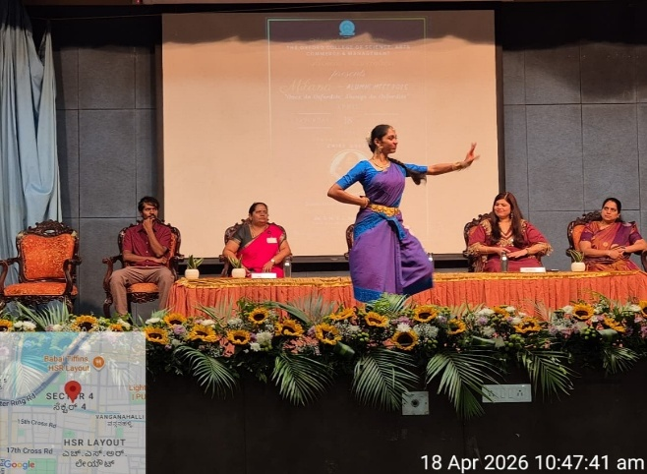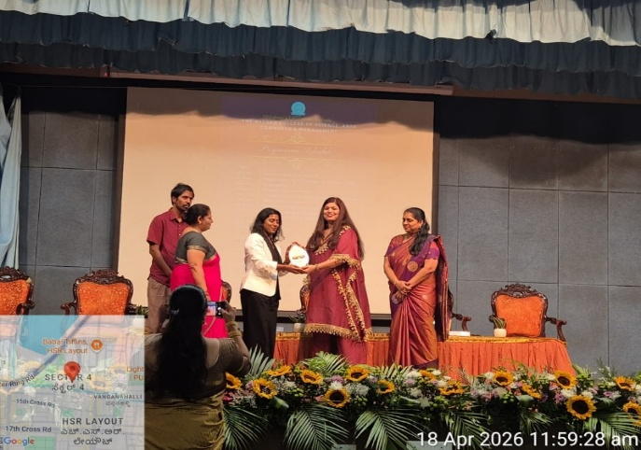

The Annual Alumni Meet Milana 2026 was successfully held on 18 April 2026 with enthusiastic participation from alumni across various batches. The event began with a grand inauguration, where the ceremonial lamp was lit by Chief Guest Shruti Bhede, along with the Principal, Chairman, and faculty members. The Chairman’s presence during the morning session added prestige to the occasion. Distinguished alumni were honored during the award ceremony, followed by inspiring interactions. After a networking lunch, the post-lunch session featured an engaging music jamming program, creating a nostalgic atmosphere. A vibrant cultural programme by students and alumni further added to the celebration. The event concluded with a heartfelt vote of thanks and the distribution of mementos, leaving behind cherished memories for all attendees.

Coordinator HOD Vice-Principal Principal

